P–V AND T–S DIAGRAMS OF THERMODYNAMIC PROCESSES
Corresponding diagrams for expansion and compression
The following diagrams show the relationship between pressure (P) and volume (V), and between temperature (T) and entropy (S), for four important ideal-gas processes. The curves are schematic; the T–S curves for constant-pressure and constant-volume processes are drawn as curves rather than straight lines.
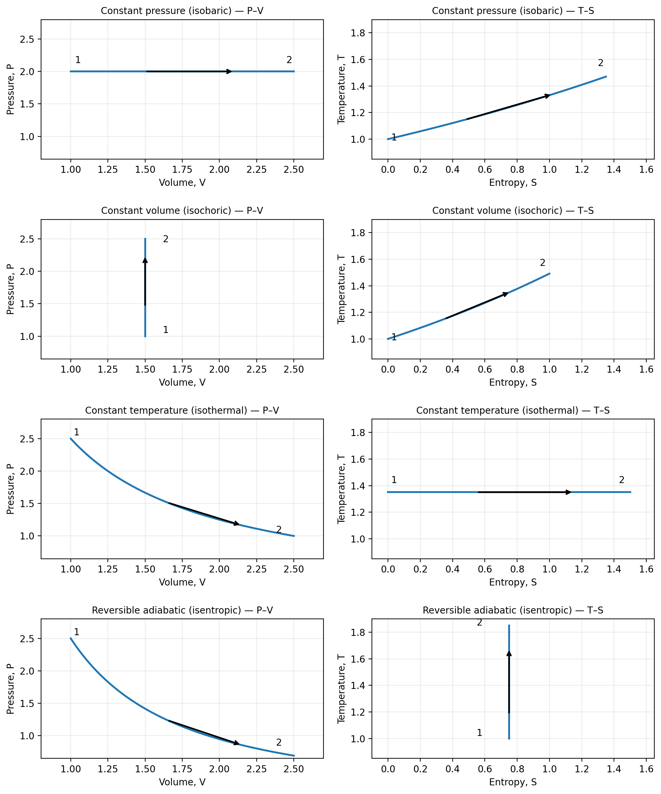
1. Constant-pressure process (Isobaric)
Pressure remains constant (P = C). On the P–V diagram, the path is a horizontal line. For an ideal gas, T is proportional to V. On the T–S diagram, the path is a curved line: T = T₁ exp[(S − S₁)/Cₚ] for constant specific heat. The curve is less steep than the constant-volume curve.

2. Constant-volume process (Isochoric)
Volume remains constant (V = C). On the P–V diagram, the path is a vertical line. For an ideal gas, pressure is proportional to temperature. On the T–S diagram, the path is also curved: T = T₁ exp[(S − S₁)/Cᵥ]. It is steeper than the constant-pressure curve because Cᵥ is less than Cₚ.

3. Constant-temperature process (Isothermal)
Temperature remains constant (T = C). For an ideal gas, PV = C. The P–V path is a rectangular hyperbola. On the T–S diagram, the path is a horizontal straight line.

4. Adiabatic process
No heat is transferred (Q = 0). For a reversible adiabatic process, entropy remains constant (isentropic process). For an ideal gas, PVᵞ = C. The P–V curve is steeper than the isothermal curve, and the T–S path is a vertical straight line. An irreversible adiabatic process is not generally isentropic.

General polytropic equation
The relative nature of several processes can be represented by the general equation:
P Vᵏ = C
Value of k | Process
0 | Isobaric (constant pressure): P = C
1 | Isothermal (ideal gas): PV = C
γ | Adiabatic and reversible: PVᵞ = C
∞ | Isochoric (constant volume): V = C

Comparison of the T–S diagrams
Process | Shape on T–S diagram
Constant pressure | Curved line (exponential for constant specific heat)
Constant volume | Curved line; steeper than constant-pressure curve
Constant temperature | Horizontal straight line
Reversible adiabatic | Vertical straight line
Note: The T–S curves above are illustrative heating/expansion directions for reversible ideal-gas processes. The reverse direction represents cooling/compression. The exact curvature depends on the gas properties and the range of states.

COMPARISON OF ALL PROCESSES ON P–V AND T–S DIAGRAMS
Combined diagrams for isobaric, isochoric, isothermal and reversible adiabatic processes
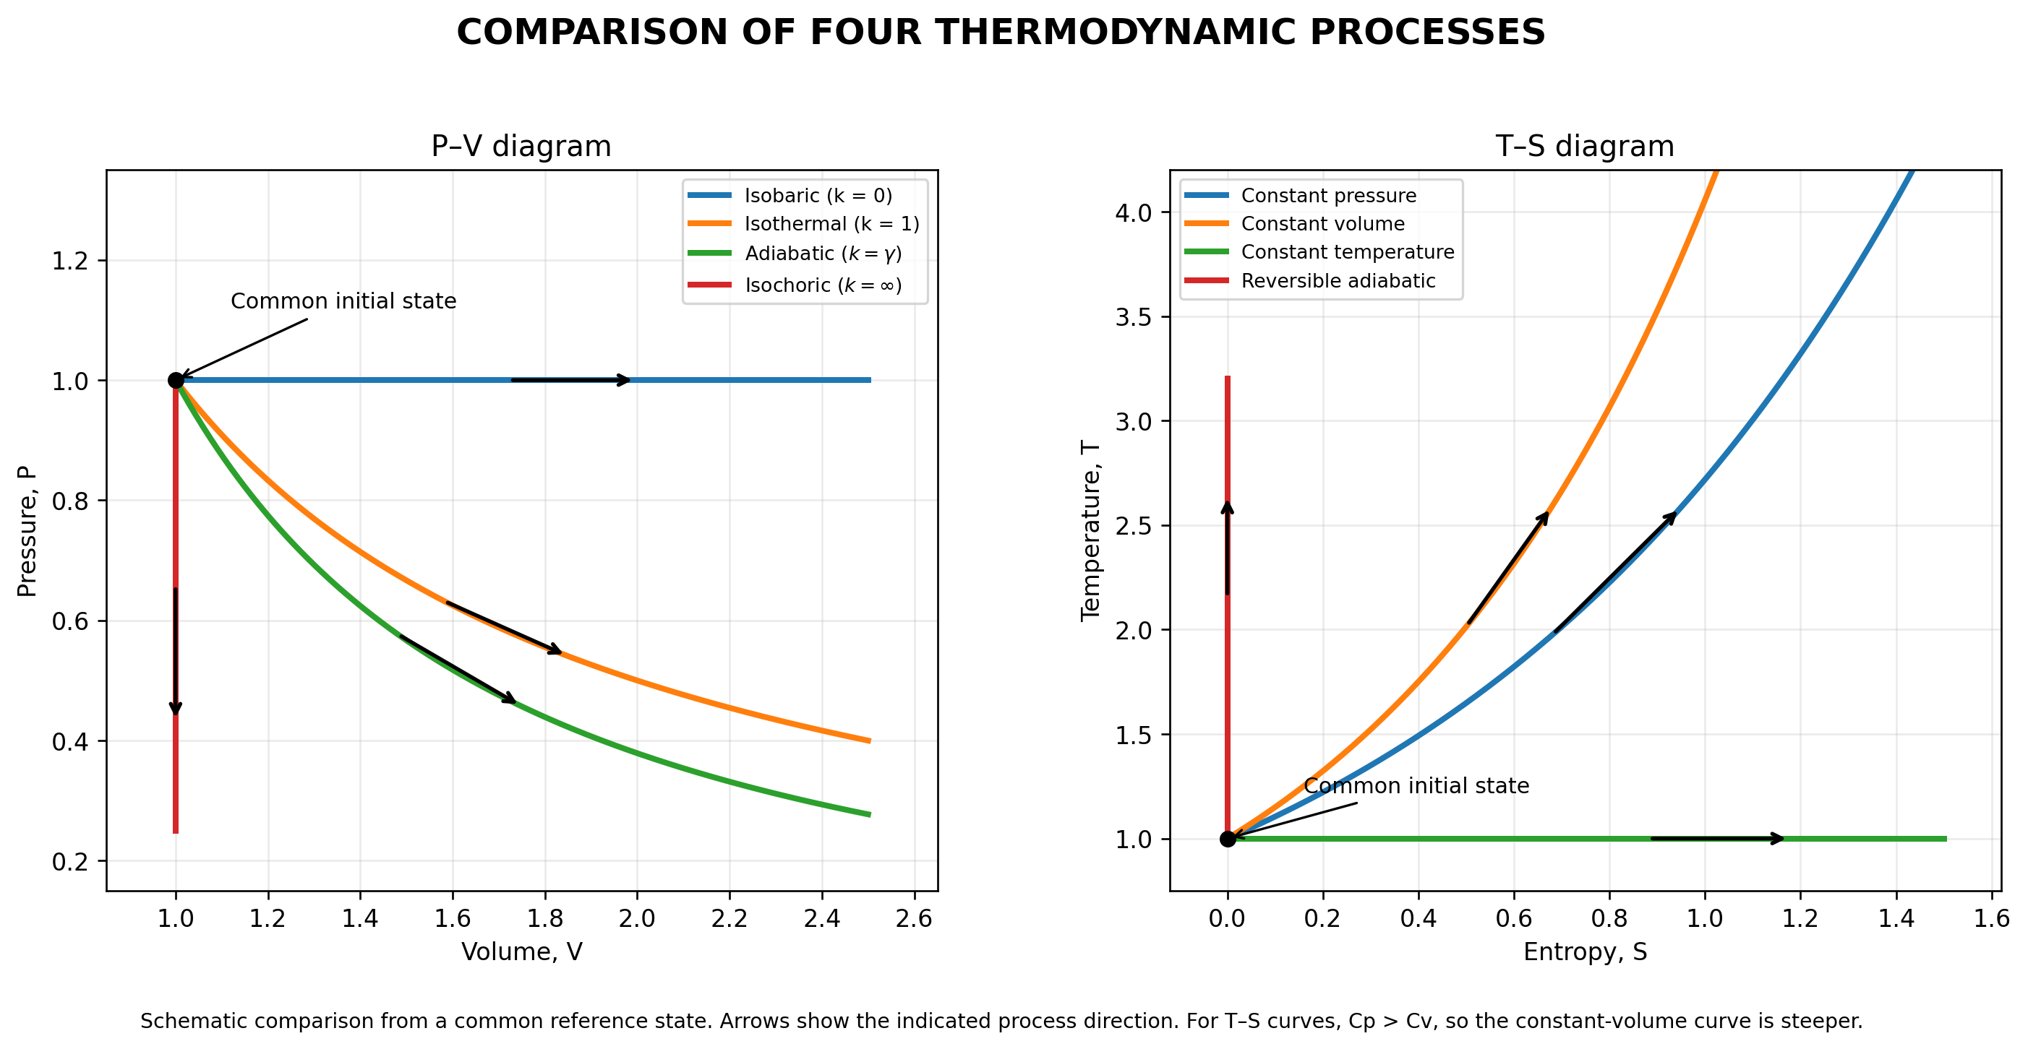
Key points
- P–V: Isobaric (k = 0) is horizontal; isochoric (k = ∞) is vertical; isothermal (k = 1) is a rectangular hyperbola; adiabatic (k = γ) is steeper than the isothermal curve.
- T–S: Constant-temperature is horizontal; reversible adiabatic (isentropic) is vertical; constant-pressure and constant-volume processes are curved, with the constant-volume curve steeper.
- The curves are schematic and are drawn from a common reference state to make their relative shapes easy to compare.

ENTROPY CHANGE IN DIFFERENT THERMODYNAMIC PROCESSES
Entropy change depends on heat transfer and the change in the system's state. For an ideal gas with constant specific heats, the following relations explain the entropy change in the four processes considered.
1. Constant-pressure process (Isobaric)
At constant pressure, adding heat raises the temperature and increases molecular energy/disorder, so entropy increases. Removing heat lowers the temperature and entropy decreases. The entropy change is:
Δs = Cₚ ln(T₂/T₁)
2. Constant-volume process (Isochoric)
At constant volume, heat transfer changes the temperature without changing the volume. Heating increases the temperature and entropy; cooling decreases both. The entropy change is:
Δs = Cᵥ ln(T₂/T₁)
3. Constant-temperature process (Isothermal, ideal gas)
For an ideal gas, internal energy depends only on temperature. Since temperature is constant, the entropy change is associated with the volume (or pressure) change. During expansion the gas occupies a larger volume and entropy increases; during compression entropy decreases. The entropy change is:
Δs = R ln(V₂/V₁) = −R ln(P₂/P₁)
4. Reversible adiabatic process (Isentropic)
No heat is transferred (Q = 0). In a reversible adiabatic process there is no entropy transfer by heat and no entropy generation, so entropy remains constant. Therefore:
Δs = 0
5. Irreversible adiabatic process
Although heat transfer is zero, irreversibilities such as friction, free expansion or mixing generate entropy. Therefore the entropy of an adiabatic system increases:
Δs > 0
Important: The sign of entropy change for isobaric and isochoric processes depends on whether the gas is heated or cooled. For isothermal ideal-gas expansion it is positive, and for compression it is negative. The statement Δs = 0 applies to a reversible adiabatic process, not to every adiabatic process.

